Jade Pearl
COSC 320-001 Lab 08: Priority Queue 4/11/2023

Lab report: I completed this lab in approximately 4 hours. Help received from Olivia (classmate) when I had errors in the preqrec.h file.

Pre-lab:
- Understand and review priority queue
- Read and understand header files: d_pqueue.h and d_heap.h

Files Created:
lab_08.cpp, edited preqqrec.h file

Lab 8
Exercise 1: Implement header file preqrec.h SOURCE CODE FOR PREQREC:
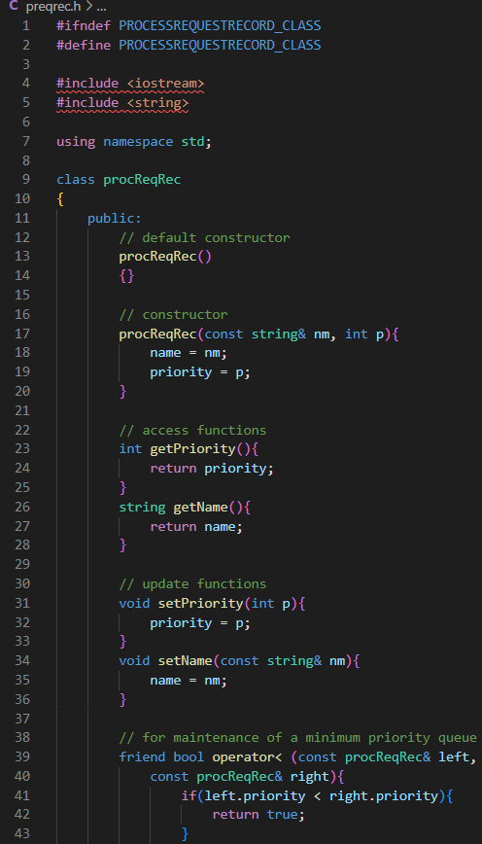
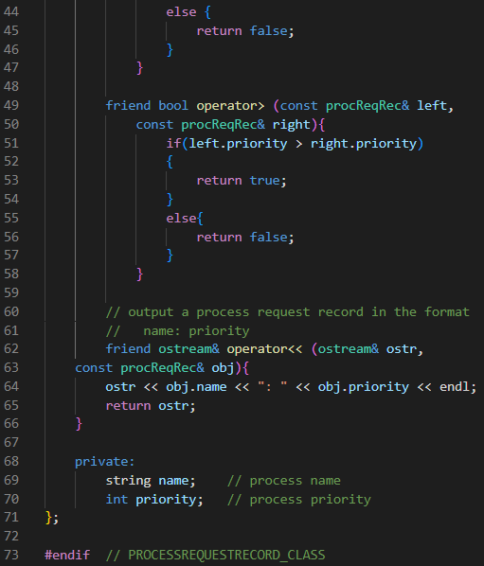
Exercise 2: Copy needed files to directory
Exercise 3a: Declare a miniPQ object mpq, and assign it to process request records, whose names are “Process A”, “Process B”, …, “Process J” and whose priority values are random integers in the range from 0 to 39
Exercise 3b: Output and delete records from priority queue until it is empty
Exercise 4: Run your program and compare it with a sample output

Source Code:
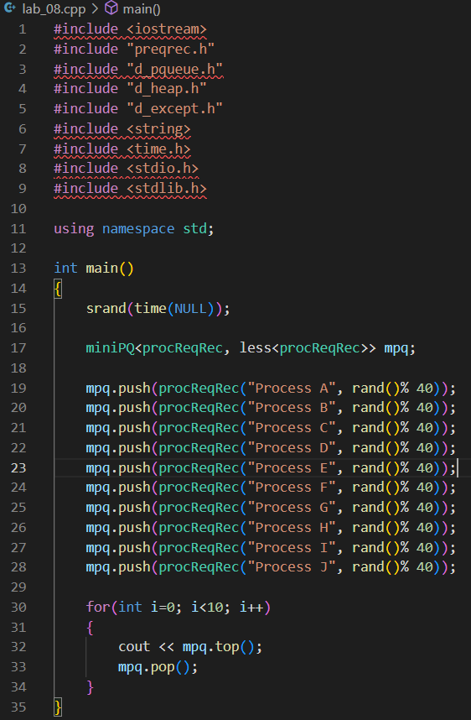

Sample Outputs:
